**Research Article**

**Isotope Localization of Ac-225 and Ac-227 in Mice**

Andrew L. Lakes 1, Dahlia D. An 1, Julian A. Rees 1, Rebecca J. Abergel 1,2

1 Chemical Sciences Division, Lawrence Berkeley National Laboratory, Berkeley, CA 94720

3 Department of Nuclear Engineering, University of California Berkeley, Berkeley, CA 94709

**Corresponding author:** Rebecca J. Abergel. [rjabergel@lbl.gov](mailto:rjabergel@lbl.gov).

**First author:** Andrew L. Lakes. [andrewllakes@gmail.com](mailto:andrewllakes@gmail.com).

**Words:** xxxx. **Figures**: xxxx. **Tables**: xxxx. **References:** xxxx

**Financial:** This work was supported by

**Running title:**

**Keywords:**

**Abstract:**

**INTRODUCTION**

1) Ac-225 isotope production

2) Ac-227 decay properties compared to Ac-225Ac-225 decays rapidly after the initial 9.9 day alpha decay into Fr-221, with a 45.5 minute pause for the half-life of Bi-213.

After this pause, there remains only 1 alpha decay (Po-213), accounting for 30% of the total alpha energy released. The Ac-227 decay chain begins with a low energy beta decay over a lengthy 7946 days, resulting in the therapeutically relevant Th-227.

The Th-227 alpha decays into Ra-223 after 18 days. After the 11.43 day alpha decay from Ra-223 intoRn-219, the remaining daughters decay with rapidity other than the 36 minute half-life of Pb-211, resulting in a final tally of5 alpha and 3 beta decays. After Pb-211 pause, there remains only 1 alpha decay (Bi-211), accounting for 20% of the total energy released. The total energy released during the Ac-227 decay chain is approximately 20% greater than the Ac-225 chain. However, the peak power output from Ac-225 occurs after only xxx hours with XXX MeV/day, whereas it takes xx days forAc-227 to hit xxx MeV/day

Ac-225 - 200 uCi = 18794542109 MeV/day @ 6.48 hours (plotoutpower) –Activity maxima is 13.68 hours (plotout) Ac-225- 200 uCi =

3) Long term dose effect of Ac-227

**MATERIALS AND METHODS**

**Materials**

IgG1 antibody was purchased from Sigma-Aldrich. Trastuzumab was graciously donated from XXXXXXXXXX. 1,4,7,10-Tetraazacyclododecane-1,4,7-tris-acetic acid-10-maleimidoethylacetamide (DOTA-MMA) was purchased from Macrocyclics, Bradford reagent was purchased from Bio-rad, and tris(2-carboxyethyl)phosphine hydrochloride (TCEP HCl), L-glutathione reduced, and all other chemicals were purchased from Sigma-Aldrich.

**Activity counting**

All activity was counted with a Perkin-Elmer Tri-Carb 2910 TR. Dilutions of radiolabeled solution activity for injection were diluted with 10 mL of Ultima Gold LLT scintillation cocktail. For biodistribution, samples were ashed in a furnace, dissolved in nitric acid, and diluted into 10 mL Ultima Gold LLT scintillation cocktail.

**Radiolabeling**

*Caution: Lu-177 and Ac-225 are radioactive isotopes that may present serious health risks when incorporated. Experiments were performed in facilities specially designed for the safe-handling of radioactive materials at the Lawrence Berkeley National Laboratory (LBNL).*

For DOTA and HOPO radiolabeling, a dry heating block was used to heat ligands to 60 ºC for 2 hours in pH 7.4 10 mM phosphate buffered saline (PBS) at 200:1 excess Ligand:Metal. For antibodies-DOTA conjugates, a dry heating block was warmed to 45 ºC and antibody-DOTA conjugates (cysteine sites) were pre-incubated for 5 minutes, dissolved in 0.1M pH 5.4 ammonium acetate. Radionuclide in 0.05N HCl was added at 200x excess Ligand:Metal for 2 hours. Starting activity was based on an aliquot of the stock solution at equilibrium upon radiolabeling. These radiolabeled solutions were washed and buffer exchanged (10x volume 5 times) into PBS of pH 7.4, and aliquots of filtrate and retentate were taken for final activity and yield verification.

**Animal Handling**

All procedures and protocols used in the described *in vivo* studies were reviewed and approved by the LBNL Institutional Animal Care and Use Committee (IACUC) and were performed in AAALAC accredited facilities.

**Animal Injection**

Contamination is achieved by intravenous injection in a warmed lateral tail vein of the challenge chelated isotope. Animals are housed in metabolism cages, per randomization group (n = 3). Urine and fecal pellets are collected daily until necropsy. Blood, liver, kidneys, spleen, heart, lungs, thymus, abdominal remainder tissue (ART), skeleton, and soft tissue remainder samples collected at scheduled necropsy and processed for analysis. Counting is done on a gamma counter and on an alpha/beta LSC counter. Samples are counted promptly after processing and repeatedly over 100 days to allow for equilibration of Ac-227 daughter products.

**Biodistribution**

**XXXXXXXXXXXXXXXXXXXXXXXXXXXXXXXXXXXXXXXX**

**Dose Modeling**

Utilizing the kinetic dose results, we created an estimated future dose for HOPO, DOTA, and Trasztuzumab Ac-225/Ac-227 constructs. The input exact dose bolus was 200 nCi for Ac-225 and 1 nCi for Ac-227 (0.5% Ac-227 contamination), and assumed to be pure actinium without daughters (all activity is only actinium at t=0). Dose modeling was performed across two regimes: 1) interpolation within the actual recorded data set (0-10 days), and 2) extrapolation of future dose assuming no further change in final time point. Between real recorded time point values of 1 hr, 4 hr, 24 hr, 4 days, 6 days (and 10 days for Trastuzumab-DOTA only), small step changes were added for interpolation. Numerically solving the standard Bateman ordinary differential equations produced an activity per time correlation. Next, using the energy output for each decay along the daughter series’, a moving average of power per count of activity (MeV/minute / CPM) for each time step was found, to get MeV/count. 100% efficiency of counting was assumed per decay. For time points within the real recorded time points, a monotonic cubic spline was used to gather activities, where activity past the real data assumes no change in biodistribution, and only decay occurs (see **Figure Sxxx**). Power per mass (MeV/(g*day)) was found per time step based on organ masses, and was numerically integrated to convert to energy per mass for conversion into units of Grey.

**RESULTS**

After injection of 50 nCi of Ac-225 construct with up to 0.5% Ac-227 contaminant to either 1) female Swiss-Webster mice with DOTA-Ac-225 or HOPO-Ac-225, or 2) female NOD SCID PDX mice with Trastuzumab-DOTA-Ac-225, biodistribution of Ac-225 and Ac-227 was investigated over several timepoints. Biodistribution was compared via recovered dose per gram (RD/g) or localization ratio (LR).

**Biodistribution**

As is typical with HOPO biodistribution in native mice, liver uptake was high for both Ac-225 and Ac-227, with lower distribution to other organs throughout 6 days after injection (**Figure 2**). LR for RD/g of Ac-225/Ac-227 tended to be at or greater than unity for the heart, lungs, kidneys, liver, and carcass. LR also trended a decrease from above unity in earlier timepoints to at or below unity in later timepoints for all organs except the spleen and ART. For the organ with greatest localized uptake with both isotopes, the liver, the LR at the final time point at 6 days was not statistically significant from unity.

DOTA biodistribution in healthy mice was also typical with activity locating heavily in the kidneys initially compared to other organs, and rapidly dropping activity with quick urine excretion (see **Figure excreta???)**. Ac-227 distribution, however, indicated lingering carcass content. Comparing LR, the Ac-227 recovery was greater than Ac-225 across the board, an opposite result to DOTA-Ac distribution.

In NOD SCID her-2 positive patient derived xenograft mice treated with targeted Trastuzumab-DOTA, RD/g biodistribution was typical where blood circulation content decreased over time, with increasing spleen as the largest uptake, followed by liver and tumor uptake. LR for Trastuzumab-DOTA-Ac was near unity for all organs other than blood and spleen. As the blood LR increased for Ac-225, so did spleen, but with only a single significant difference at the final 10-day timepoint for the spleen LR (n=5, mean = 2.94 ± 1.43 stdev., one-tailed P-value = 0.02 vs. unity).

There is a 1:5-10 ratio of 225/227 dose for DOTA (10-100:1 225/227) vs DOTA-Tras (100-500:1 225/227) that can be seen from the dose biodistribution (**Figure S2**). Even though the Ac-227 dose is higher for the antibody compared to DOTA-only with Ac-227, the Ac-225 dose with the antibody is 5-10 times higher than the Ac-227 dose with the antibody, leaving more therapeutic headroom (**Figure S2**).

**Calculated dose**

As far as dose, with the antibody, the spleen gets ~20 Gy over 50 days for 225, and ~33 Gy over 20 years for 227. For 225 antibody that gives a maxima of 1 Gy/day at 6 days, and 0.0058 Gy/day at 200 days for 227 antibody.

For instance, if real time points are from 0-10 days, and we extrapolate out to Ac-227 half-life (7946 days), cubic spline is used between 0-10 days, and from 10.25-7946 days are extrapolated by the final activity and decayed as if stationary according to the Ac-22X moving power average per timepoint. The difference is small for Ac-225 since it is already at equilibrium, but it is significant for Ac-227.

**DISCUSSION**

**CONCLUSIONS**

**REFERENCES**

Use the "Insert Citation" button to add citations to this document.

**FIGURES**

**A**

**B**

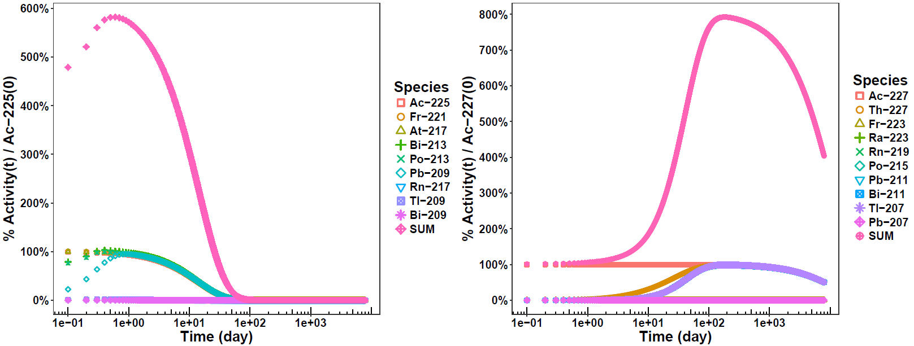

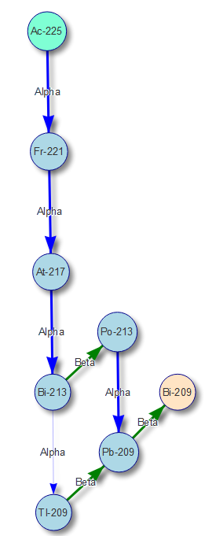

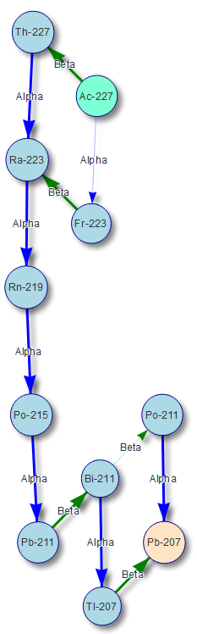 

**Figure 1.** Comparison of **A)** Ac-225 and **B)** Ac-227 decay. **Left:** Vertical placement is in relation to proton count. Parent is in teal, final daughter is in salmon, intermediate species with >0.1% incidence are blue. Line thickness indicates probability (thicker is greater probability). **Right:** Species activity in relation to pure actinium parent at t=0 [% Activity of Species(t) / Ac-22X(0)]. SUM is total of all species.

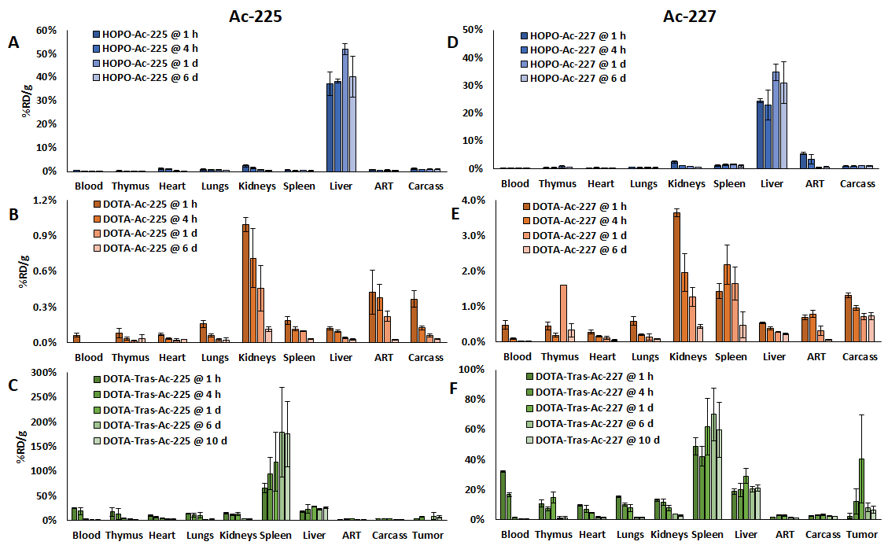

**Figure 2.** %Recovered dose per mass (%RD/g).

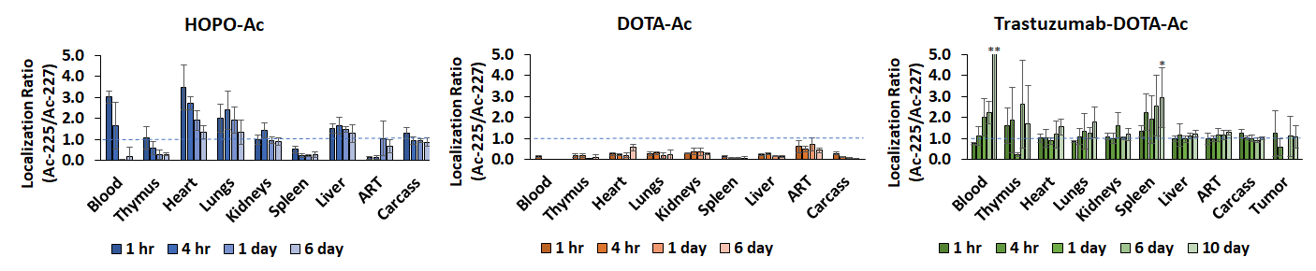

**Figure 3.** Localization ratio (recovered dose per mass of Ac-225/Ac-227). *P-value < 0.05. **value out-of-scale, mean 10.8 ± 19.0 stdev.

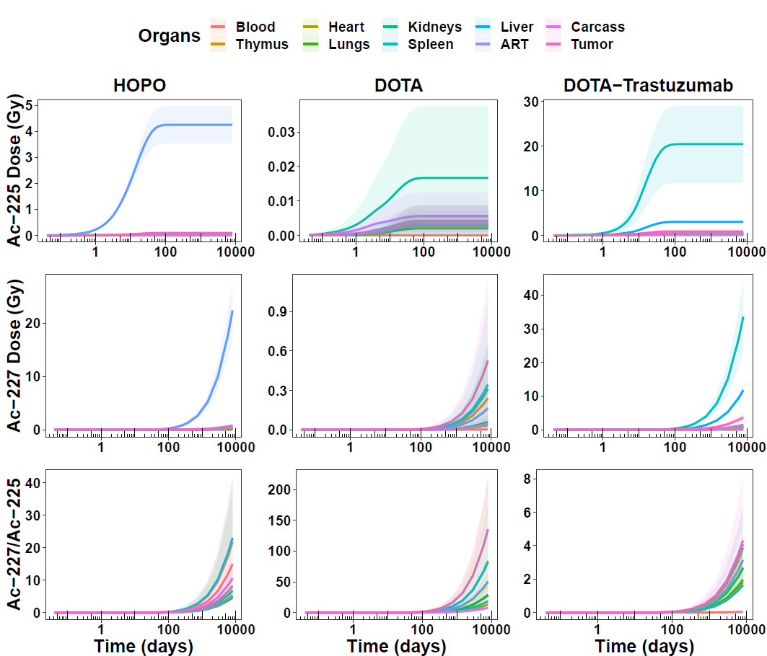

**A**

**B**

**C**

**D**

**E**

**F**

**G**

**H**

**I**

**Figure 4.** Dose over one Ac-227 half life.

**A**

**B**

**C**

**D**

**E**

**F**

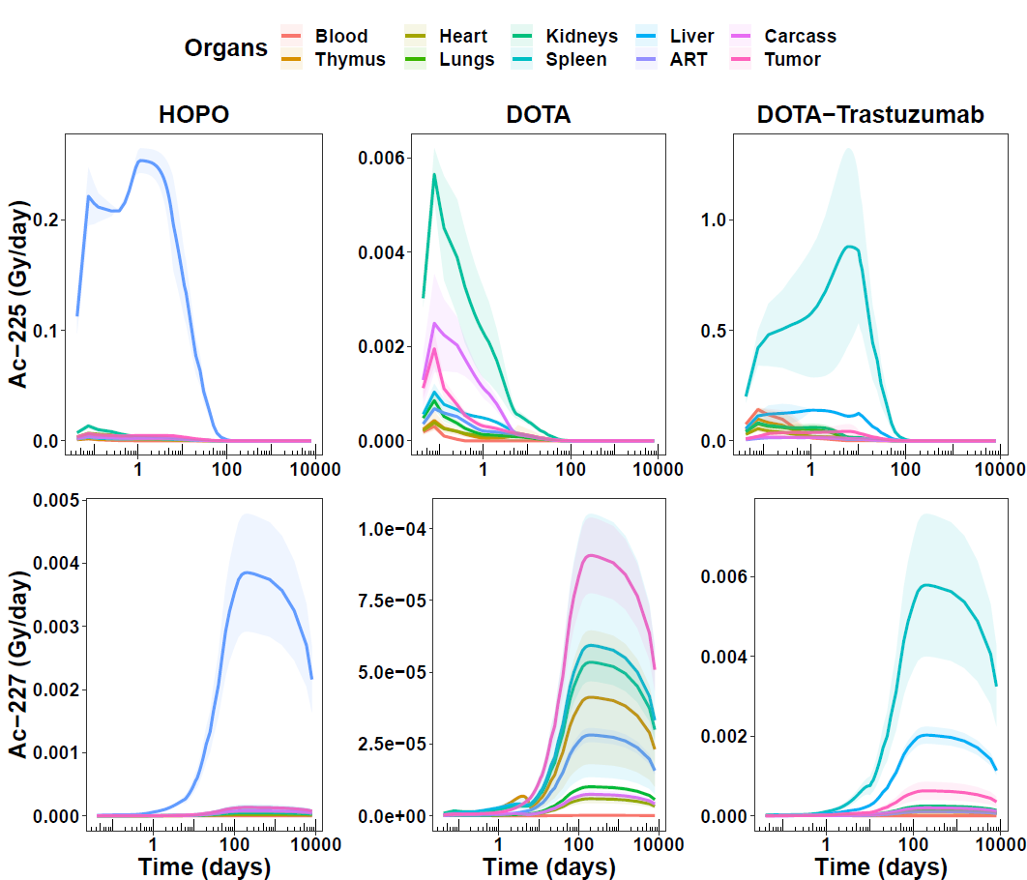

**Figure 5.** Dose per day over one Ac-227 half life.

**DISCLOSURE**

The authors have no disclosures.

**ACKNOWLEDGEMENTS**

This work was supported by

**SUPPLEMENTAL INFORMATION**

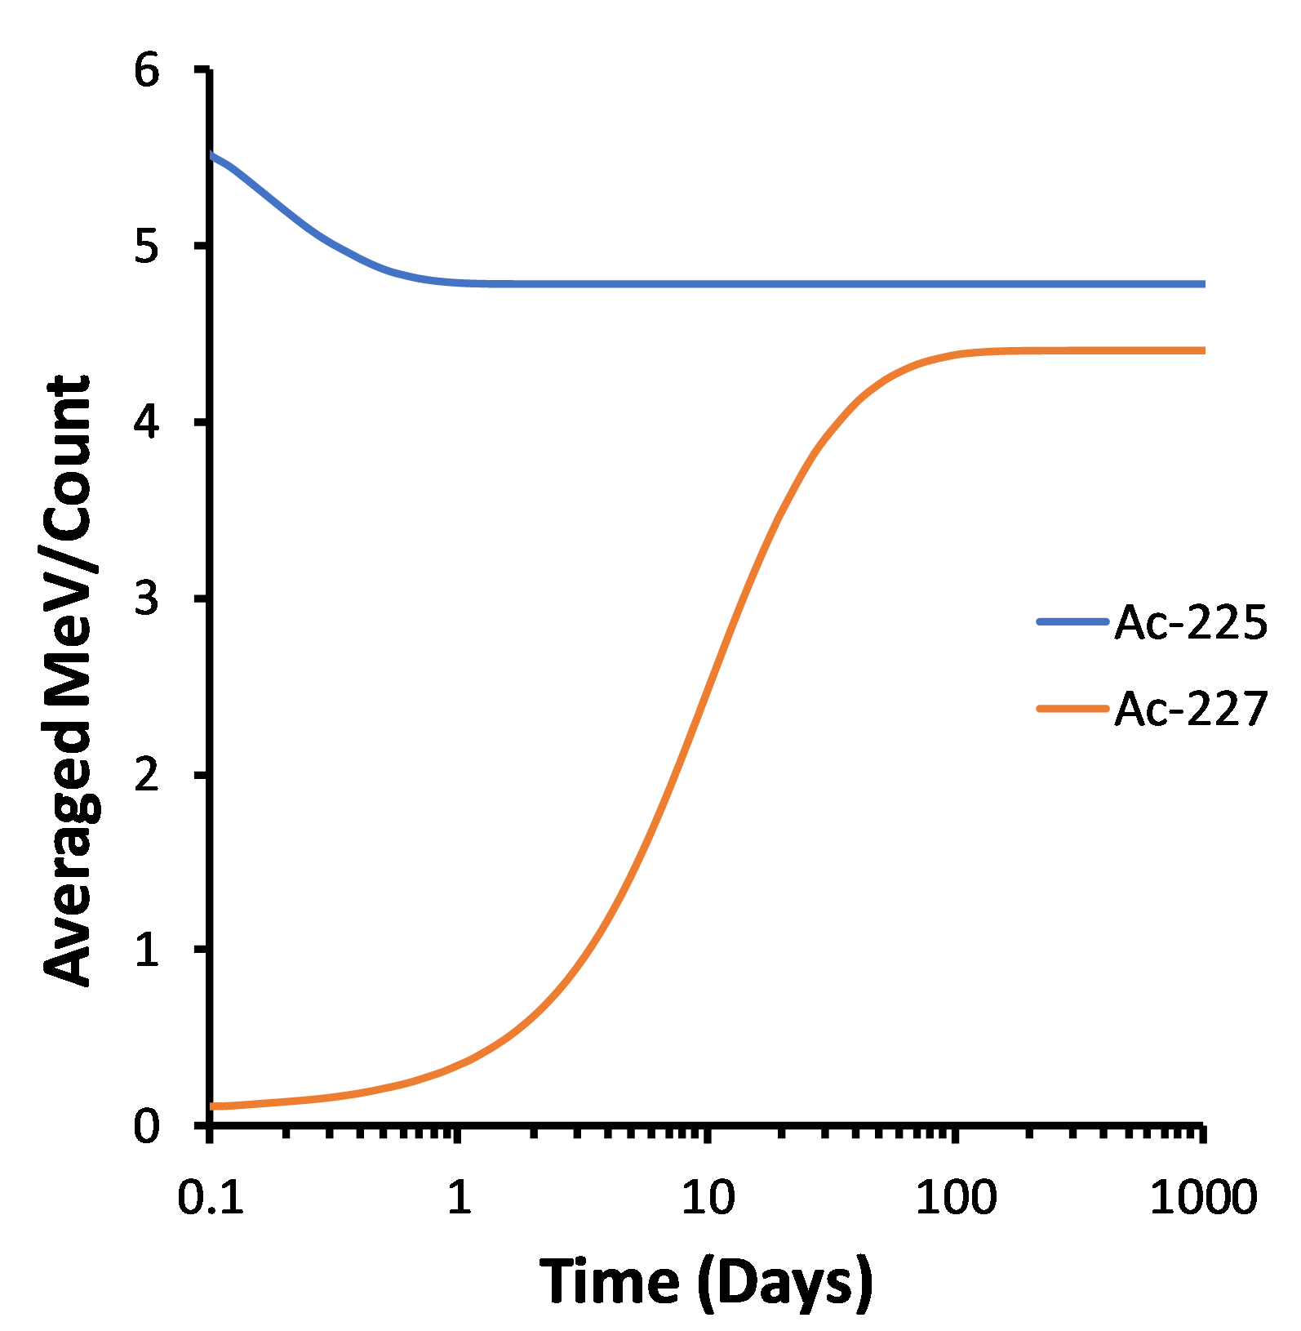

**Figure S1.** Starting with pure actinium species without daughters, equilibrium of average energy per destruction (counting both alpha and beta species) occurs rapidly within one day for Ac-225, and only after 100 days for Ac-227.

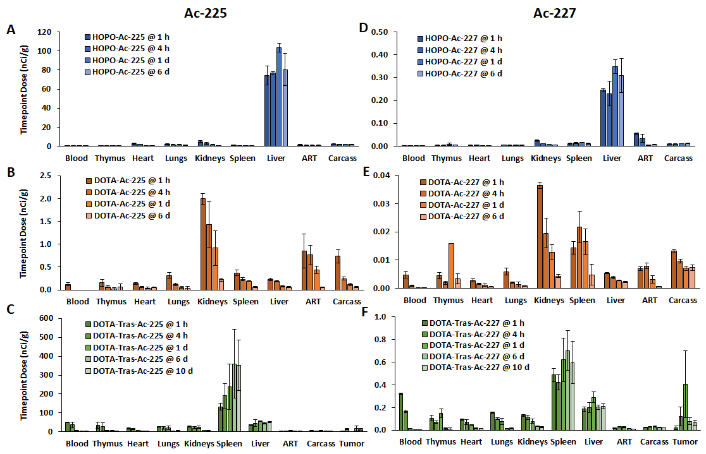

**Figure S2.** Dose biodistribution with exactly 200 nCi Ac-225 and 1 nCi Ac-227 per mouse, based on %RD/g plots in **Figure 2**.

**Figure S3.**